A Picture Perfect Smile:
The Secret to Attractiveness at Any Age
It’s no secret that we only have one chance to make a lasting first impression, which can often shape how we are perceived and remembered in both our social and professionals lives. A new study by the American Academy of Cosmetic Dentistry (AACD) finds that a great smile can be our greatest asset – a feature that remains attractive even as we age and goes a long way in nailing an incredible first impression.
Perhaps this is why most people consider their smiles a worthwhile investment and would be willing to open up their wallets to preserve their pearly whites.
WITHSTANDING THE TEST OF TIME:
Perhaps a person’s smile makes such an impact on first impressions because we believe it is the one feature that will always be attractive no matter how old we get.
A Timeless Smile. About (45%) of survey participants agree a smile is the most attractive feature, no matter their age. Conversely, very few think that the body (10%), hair (6%), or legs (5%) are as appealing as we age.
Roughly half (54%) of respondents ages 50+ attest that a smile can withstand the test of time most attractively as someone ages, compared with 39 percent of 18-49 year-olds who feel the same.
WORTH THE INVESTMENT:
Given the importance of a perfect smile, most people surveyed would be willing to spend money safeguarding their teeth as they age.
Preventative Measures. A whopping 80 percent admit they would spend money to maintain a youthful appearance. More women than men (84% vs. 75%) are willing to make this investment. And since many believe that turning 30 gives you plenty to dread, it’s not surprising that people ages 30-39 are more likely than any other age groups (88% vs. 78%) to consider shelling out money for their looks.
Worth the Fight. More than three in five (62%) of them would spend their money to maintain the quality of their teeth.
Not Worth the Money? And while they recognize that their hair or legs are not as likely to remain as attractive as their smile once they age, fewer would be willing to spend money to address thinning hair (33%) or unsightly veins on their legs (28%) than they would on their teeth.
Last on the List. Other aging imperfections or flaws such as excess weight (48%), dark under-eye circles (33%), and wrinkles (31%) are more likely to be ignored than their teeth.
LEVERAGE YOUR GREATEST ASSET WHEN MAKING A FIRST IMPRESSION:
There's only one chance to make a lasting first impression and a smile can go a long way.
Say Cheese. Close to one in two (48%) people believe that a smile is the most memorable feature after first meeting someone – more so than the first
thing a person says (25%). Those ages 50+ are more likely than their 18-49 year-old counterparts (52% vs. 45%) to remember a smile when first introduced to someone.
The Minor Things. And nothing else even comes close to the impact a great smile can make. Fewer Americans would be likely to remember a person’s clothes (9%) or the way he or she smelled (8%) after meeting for the first time.

BEST FACE FORWARD:
More than a third of respondents view people with a flawed smile to be less attractive (37%) and less confident (25%) than those with perfect teeth. More women than men (40% vs. 35%) agree that an imperfect smile makes someone less appealing than a person with a perfect smile.
INFOGRAPHICS ON FOLLOWING PAGES
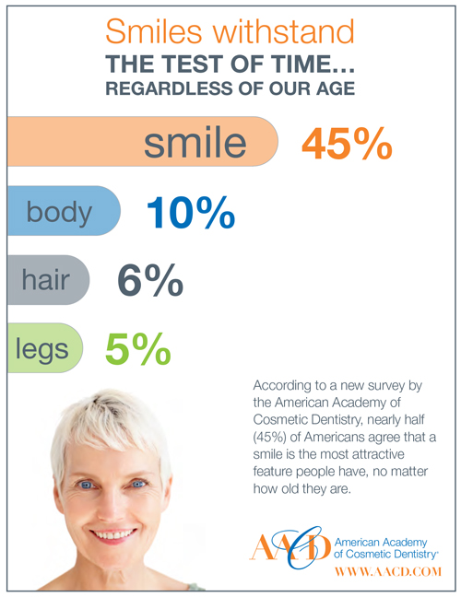
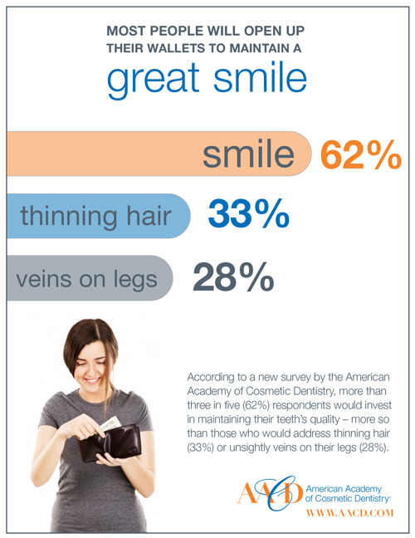
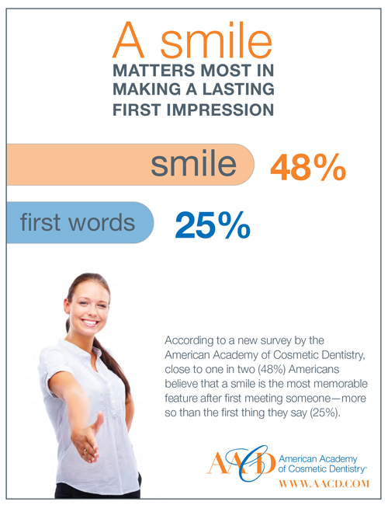
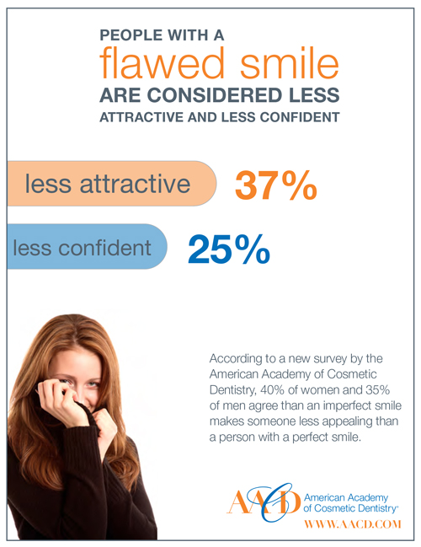

About the survey: The AACD Smile survey was conducted by Kelton between August 17th and August 23rd, 2012 among 1,018 nationally representative Americans ages 18 and over, using an email invitation and an online survey. Results of any sample are subject to sampling variation. The magnitude of the variation is measurable and is affected by thenumber of interviews and the level of the percentages expressing the results. In this particular study, the chances are 95 in 100 that a survey result does not vary, plus or minus, by more than 3.1 percentage points from the result that would be obtained if interviews had been conducted with all persons in the universe represented by the sample. The margin of error for any subgroups will be slightly higher.

